1. **Look at the poster and read the text**



Come and join our lunchtime yoga class with experienced yoga teacher Divya Bridge!

When? Every Tuesday at 1.30 p.m.

Where? Meeting Room 7

How much? £10 for four 30-minute classes.

What to bring? Comfortable clothes. Divya will provide the yoga mats.

How to join? Write to Sam at Sam.Holden@example.com

We can only take a maximum of 20 in the room, so book now!

1. **Read the holiday home advert**

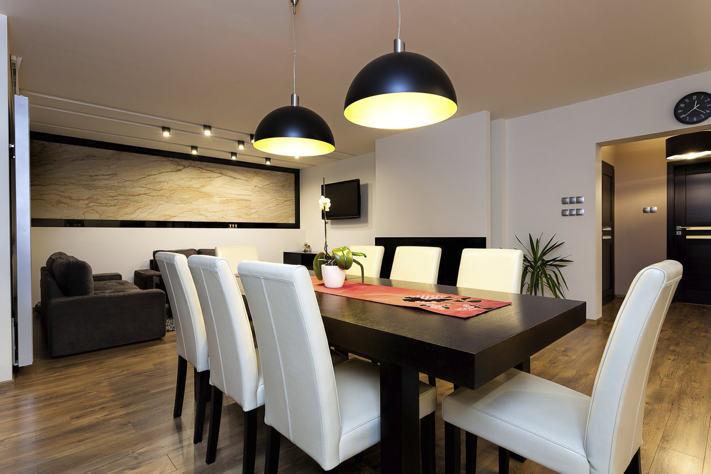

City flat

Beautiful two-bedroom city flat five minutes' walk from the cathedral. Fully equipped kitchen, living room with a large sofa and chairs, big TV and balcony. The balcony has space for four people to sit and gets the sun in the mornings, and the flat is light and warm. It has Wi-Fi and fast internet. The upstairs bedroom sleeps four people, with two double beds; the downstairs bedroom sleeps two in single beds. The flat is perfect for families and is near shops, bars and restaurants.

1. **Read the job advert**



Do you like cars? Are you friendly and do you like chatting with people? Would you like to make £200 a day selling cars? If you answered yes to the above questions, we’d like you to be on our team! (Driving licence required.)

**Company**

Motor Ground is a car sales company that buys and sells used cars.

**Location**

Chennai, India

1. **Read the poster for exam candidate**



***Poster 2***

BEFORE THE EXAM

* Have your ID card ready.
* Listen to the instructions.
* Arrive 10 minutes before exam.

IN THE EXAM

* Mobile phones switched off and put away.
* ID card visible on the desk.
* No talking.
* No food or drinks in exam room.